Chapter 7, Solution 92.

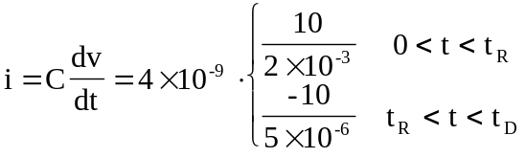

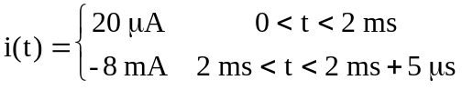

which is sketched below.
20 A
i(t)
t
-8 mA
5 s
2 ms
(not to scale)

